DR. AMBEDKAR COLLEGE, DEEKSHA BHOOMI, NAGPUR

Date: 16thDecember 2022
Name of the Programme: Guest Lecture on “Gender Sensitization”
Resource Persons: Shri. Anand Chandrani
Organised by: Department of Law (Induction Program) And Internal Complaints Committee
Name of Program Co-ordinators: 1. Dr. Sandhya Kalamdhad
2. Mrs. Vaishali A. Sukhdeve
Number of Attendees: Around 180
Name of Venue: Seminar Hall, Department of Law

NOTICE
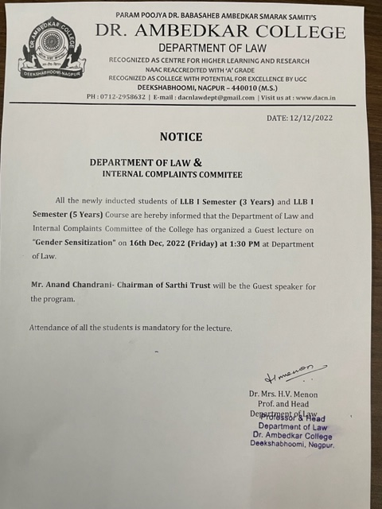
REPORT ON GENDER SENSITIZATION

TheDepartment of Law and Internal Complaints Committee of Dr. Ambedkar College, Deekshabhoomi Nagpur, hasorganised a gender sensitization programon16thDec 2022 for the newly inducted Students of LLB 3 year and LLB 5 Year courses.Around 180studentsattended the session.
Mr. Anand Chandrani- Chairman of Sarthi Trust wasinvited as guest speaker in the program. Mr. Nikunj Joshi, CEO of Sarthi Trust and two transgender, Anchal Verma and Mohini were prominently present to sensitize about the rights of third gender.
Dr. Hema Menon, Professor and Head Department of Law gave the welcome addressand explained the importance of gender sensitization.
Mr. Anand Chandranistarted the session with the introduction of their organization and the nature of work they do for the LGBTQ community in the Vidarbha region and appreciated and recognized the efforts taken by its members in sensitizing the issues of LGBTQ community. Later, Mr. Nikunj Joshi was asked to take over the session, who in a very detailed manner explained the different categories of third gender. He threw light on the problems faced by the transgenders by citing the live examples which were in contact with the organization. Anchal Sharma, one of transgender shared her own life experiences with the students, and brought the bitter reality before the students that how they are denied the basic Human rights.
This was followed by the question-and-answer session wherein the different students asked the diverse questions which was answered by the speakersto the satisfaction of the students. The members of the trust were delighted by the step taken by the institution to invite the transgenders for sensitization program and thus appreciated the same.
The Programme was conducted by Mrs. Vaishali A. Sukhdeveand concluded with vote of thanks proposed by Dr. Sandhya Kalamdhad, Professor and Co-ordinator ofInternal Complaints Committee of the college.

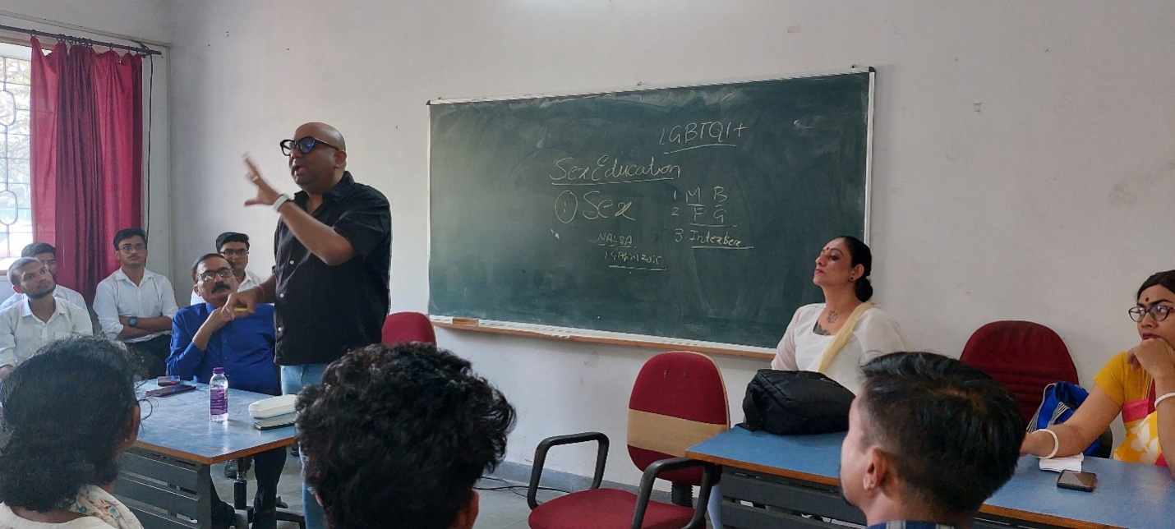
Mr. NIKUNJ JOSHI SENSITIZING THE STUDENTS ON RIGHTS OF LGBTQ

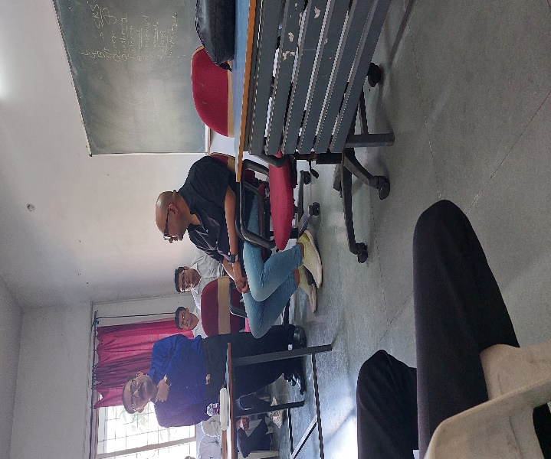
Mr. ANAND CHANDRANI ADDRESSING THE GATHERING

